VIETNAM - KOREA UNIVERSITY OF INFORMATION
AND COMMUNICATION TECHNOLOGY
FACULTY OF COMPUTER SCIENCE


REPORT
CLOUD COMPUTING
TOPIC: INTER PROCESS COMMUNICATION
SHARED MEMORY
TOPIC: INTER PROCESS COMMUNICATION
SHARED MEMORY
TOPIC: INTER PROCESS COMMUNICATION
SHARED MEMORY
TOPIC: INTER PROCESS COMMUNICATION
SHARED MEMORY
TOPIC: INTER PROCESS COMMUNICATION
SHARED MEMORY
TOPIC: INTER PROCESS COMMUNICATION
SHARED MEMORY
TOPIC: INTER PROCESS COMMUNICATION
SHARED MEMORY
TOPIC: INTER PROCESS COMMUNICATION
SHARED MEMORY
TOPIC: A STEP-BY-STEP GUIDE TO DEPLOYING FULL-STACK WEB AND POSTGRESQL TO RENDER WITH CI/CD

Group members : Nguyen Quang Nhan

Instructor : Dr. Hoang Huu Duc

Da Nang, November 2026
VIETNAM - KOREA UNIVERSITY OF INFORMATION
AND COMMUNICATION TECHNOLOGY
FACULTY OF COMPUTER SCIENCE

REPORT
CLOUD COMPUTING
TOPIC: INTER PROCESS COMMUNICATION
SHARED MEMORY
TOPIC: INTER PROCESS COMMUNICATION
SHARED MEMORY
TOPIC: INTER PROCESS COMMUNICATION
SHARED MEMORY
TOPIC: INTER PROCESS COMMUNICATION
SHARED MEMORY
TOPIC: INTER PROCESS COMMUNICATION
SHARED MEMORY
TOPIC: INTER PROCESS COMMUNICATION
SHARED MEMORY
TOPIC: INTER PROCESS COMMUNICATION
SHARED MEMORY
TOPIC: INTER PROCESS COMMUNICATION
SHARED MEMORY
TOPIC: A STEP-BY-STEP GUIDE TO DEPLOYING FULL-STACK WEB AND POSTGRESQL TO RENDER WITH CI/CD

Group members : Nguyen Quang Nhan

Instructor : Dr. Hoang Huu Duc

Da Nang, November 2026

LECTURER’S COMMENTS

Instructor’s Signature:

PhD. Hoang Huu Duc

ACKNOWLEDGMENT
We would like to extend our heartfelt gratitude to PhD.Hoang Huu Duc for his valuable guidance, encouragement, and support throughout the completion of our project “A Step-by-Step Guide to Deploying Full-Stack Web and PostgreSQL to Render with CI/CD.” His insightful lectures and detailed explanations helped us gain a deeper understanding of system cloud computing. Under his supervision, we learned essential technical concepts such as shared memory and synchronization, which served as the foundation for our work.
Moreover, we developed important research, teamwork, and analytical skills through his continuous motivation and constructive feedback. His patience, enthusiasm for teaching, and dedication inspired us to approach each challenge with confidence and curiosity. We are truly grateful for the supportive learning environment he created, which allowed us to grow both academically and personally.

Contents
LECTURER’S COMMENTS i
ACKNOWLEDGMENT ii
LIST OF FIGURES v
CHAPTER 1: INTRODUCTION 1
1.1 Overview of System Programming 1
1.1.1 Concept of System Programming: 1
1.1.2 General Overview of System Programming: 1
1.1.3 History of System Programming: 2
1.2 Inter-Process Communication (IPC): 2
1.3 Main Methods of Interprocess Communication: 2
1.3.1 Socket Communication 2
1.3.2 Message Queues 3
1.3.3 Shared Memory 3
1.3.4 Pipes: 4
1.3.5 Remote Procedure Call (RPC): 4
1.3.6 Synchronization Mechanism: 4
1.4 Introduction to Shared Memory 5
1.4.1 Concept of Shared Memory: 5
1.4.2 How Shared Memory Works 5
1.5 Overview of Key Technologies 6
1.5.1 Virtualbox: 6
1.5.2 The C Programming Language: 7
CHAPTER 2: DESIGN AND IMPLEMENTATION 9
2.1 Applications of Shared Memory 9
2.1.1 Multi-process and Multi-threaded Systems 9
2.1.2 Database Systems 10
2.1.3 Embedded and Real-Time Systems 10
2.1.4 Distributed Task Processing 11
2.1.5 Inter-Application Communication 11
2.2 Operational Mechanism of Shared Memory 11
2.2.1 Create Shared Memory 12
2.2.2 Attach to Memory Area 12
2.2.3 Communication and Data Exchange 12
2.2.4 Access Coordination 12
2.2.5 Detaching and Releasing Memory 13
2.3 Advantages and Disadvantages of Shared Memory 13
2.3.1 Advantages of Shared Memory 13
2.3.2 Limitation of Shared Memory 13
CHAPTER 3: DEMONSTRATION OF SHARED MEMORY 15
3.1 Shared memory Applications 15
3.2 Synchronization and Memory Management 15
3.2.1 Shared Memory Structure 15
3.2.2 1.1.1 Shared Memory Structure 15
3.2.3 Memory Allocation and Access 16
3.2.4 Synchronization Strategies Implemented 16
3.3 Demo images 18
CONCLUSION 23
Summary of Findings 23
Evaluation of Shared Memory IPC 23
Limitations Encountered 24

LIST OF FIGURES
Figure 1 Shared Memory 5
Figure 2 Logo Virtual Box 6
Figure 3 C Programming Language 7
Figure 4 The server process successfully initializes the Shared Memory segment and the Semaphore 18
Figure 5 Client 1 (daily_01) logs in and sees initial menu 18
Figure 6 Client 2 (daily_02) logs in and sees initial menu 19
Figure 7 Client view seating chart 19
Figure 8 Client 1 proceeds to book a ticket 20
Figure 9 Client 2 booked a ticket and it was already booked by someone else. 20
Figure 10 Client 1 proceeds to cancel the ticket. 20
Figure 11 Check the tickets that have been booked. 21
Figure 12 Search for tickets by phone number 21
Figure 13 View process shared memory 22

INTRODUCTION

OVERVIEW OF CLOUD COMPUTING

What is Cloud Computing?
Cloud computing is a technology model that allows accessing and sharing services and computing resources over the internet. Instead of having to own and manage their own servers and IT infrastructure, organizations can use virtual servers and store data in remote data centers managed by service providers cloud. This helps reduce costs, increase flexibility, and ensure easy scalability for businesses.
Cloud computing has become an important part of most business and information technology fields, providing a foundation for application development, data storage, and deployment of online services..

Essential Characteristics of Cloud Computing:
Special characteristics of system programming:
- Programmers make assumptions about the hardware and other details of the system on which the programs run, and they often exploit this information (for example, using known algorithms more efficiently on specific hardware).
- Usually, a low-level programming language is used because:It can execute in resource-constrained environments.
System programming enhances or extends the functions of an operating system and may include components such as drivers, utilities, and updates. These allow for efficient management of hardware resources such as memory, file access, I/O operations, device management, and process management, including process control and multitasking.
An example is an operating system, which serves as an interface between the user, application software, and computer hardware. The OS provides an environment that allows users to efficiently execute other programs. It includes a set of system programs, and the functions of the operating system include storage management, file processing, memory management, scheduling, CPU and device management, error handling, process control, and more.

History of System Programming:
Initially, programmers wrote invariants using Assembly language.
Experiments with hardware support through high-level languages in the 1960s led to the emergence of languages such as BLISS and BCPL.
However, the C programming language, which played a crucial role in the creation of UNIX, became widely used and spread everywhere during the 1980s.
Today, embedded uses for C++ have been found. Implementing core parts of operating systems and networking requires system software developers.
For example, implementing paging (via virtual memory) or device drivers are tasks handled by system programmers

Inter-Process Communication (IPC):
Modern operating systems allow multiple processes to run in parallel to utilize hardware resources.However, since each process has its own memory space, they cannot directly access each other’s data.
Interprocess Communication (IPC) mechanisms were developed to allow processes to exchange data, signals, or synchronize activities.
IPC is essential in:
- Multi-process applications,
- Distributed systems,
- Parallel computing.
With IPC, independent processes can coordinate and share resources safely and efficiently.

Main Methods of Interprocess Communication:

Socket Communication
A socket acts as an endpoint for bidirectional communication between two processes. It can operate either locally on the same host or across different machines connected through a network. Sockets are fundamental to network programming and are the backbone of protocols such as TCP/IP (Transmission Control Protocol/Internet Protocol) and UDP (User Datagram Protocol).
Socket communication supports both connection-oriented (reliable) and connectionless (unreliable but faster) modes. In client–server architectures, the server listens on a specific port for incoming connections, while clients initiate communication using the server’s IP address and port. Sockets are widely used for applications such as web servers, chat systems, and file transfer utilities.

Message Queues
A message queue is an IPC mechanism that allows processes to communicate asynchronously by sending and receiving discrete messages through an intermediate queue maintained by the operating system. Processes do not need to be active simultaneously; one process can send a message, and another can read it later when ready.
This approach provides loose coupling between processes, enhancing system flexibility and scalability. Message queues are useful in distributed systems, where processes might run on separate machines and need to exchange structured data safely without a direct connection.

Shared Memory
Shared memory is the fastest IPC mechanism, as it enables multiple processes to directly access the same physical memory region. Instead of copying data through the kernel or intermediate buffers, processes can read and write within a shared memory segment, resulting in minimal overhead.
However, since multiple processes can modify the same data simultaneously, synchronization techniques such as semaphores, mutexes, or condition variables must be used to prevent race conditions and ensure data consistency. Shared memory is often used in real-time systems, scientific simulations, and applications requiring large data exchanges.

Pipes:
Pipes are one of the earliest inter-process communication mechanisms in Unix and Linux systems, providing a one-way data flow between processes where one process writes information into the pipe and another reads it in sequence, working in a way similar to file input and output operations, there are two main types of pipes, unnamed pipes which are typically used for communication between a parent process and its child process, and named pipes or FIFOs which allow unrelated processes to communicate through a special file that serves as a data conduit, this technique is often seen in command-line operations where the output of one program becomes the input of another such as in the command ls | grep keyword, making pipes a simple but powerful method for transferring data between processes in the same system

Remote Procedure Call (RPC):
Remote Procedure Call also known as RPC is a method that allows one process to execute a function or procedure located in another process possibly on a different machine as if it were a local function, this abstraction hides the complexity of communication by automatically managing message exchange, data serialization, and response handling, RPC plays a crucial role in distributed computing and service-oriented architectures since it enables seamless function calls across networks, frameworks such as gRPC SOAP and CORBA have adopted RPC concepts to build scalable and platform-independent systems that can communicate efficiently over different environments

Synchronization Mechanism:
When multiple processes or threads share resources or communicate simultaneously synchronization mechanisms are essential to ensure that data remains consistent and that the system avoids concurrency issues, semaphores are used to control access to limited resources by counting available slots, mutexes or mutual exclusion objects allow only one process to access a critical section at a time ensuring exclusive use, and monitors encapsulate shared data together with operations that maintain correct sequencing and atomicity, proper synchronization helps prevent race conditions deadlocks and resource starvation thus ensuring stable and reliable inter-process communication in complex systems

Introduction to Shared Memory

Concept of Shared Memory:

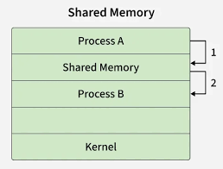
Figure 1 Shared Memory
Shared Memory is a special memory region that allows multiple processes to access and manipulate the same data space directly. Instead of sending data through intermediate channels like pipes or message queues, shared memory allows processes to read and write directly to the same physical memory, making it the fastest IPC method.
This approach is commonly used in:
- Real-time systems,
- High-volume data processing applications,
- Audio-video streaming or low-latency data transfer.

How Shared Memory Works
In a shared memory communication model, there are two main process roles:
Producer: creates and writes data to the shared memory,
Consumer: reads and uses the data from shared memory.
Operation steps:
- Create shared memory: A process (usually the producer) creates a shared memory segment with a unique key.
- Attach to shared memory: Other processes (consumers) use the same key to attach the shared memory to their address space.
- Data transfer: Producer writes and consumer reads directly in RAM without intermediate files or sockets.
- Synchronization: Use semaphores, mutexes, or monitors to prevent race conditions during concurrent access
- Detach and remove: After use, processes detach from the memory and the creator removes it to avoid memory leaks.

Overview of Key Technologies

Virtualbox:

Figure 2 Logo Virtual Box
VirtualBox is a free and open-source virtualization software that allows users to run virtual machines (VMs) on a physical computer.
VMs operate independently, providing an ideal environment for testing operating systems such as Linux or Windows, creating isolated environments, accessing potentially unsafe websites, or testing software safely.
VMs can also access USB devices, shared folders, and printers.
Key features:
- Run multiple OS simultaneously on a single physical machine, including Linux, Windows, BSD, MS-DOS,
- Support for creating and managing virtual machines easily, including snapshots for saving VM states,
- Easy to launch, pause, clone, and migrate VMs between hosts,
- Allocate or remove hardware resources (CPU, memory, disk) to optimize VM performance,
- Network configuration options for VMs including NAT, bridged, host-only, and internal networking,
- Compatible with VirtualBox Extension Pack for additional features like USB 2.0/3.0 support, remote desktop, and disk encryption.


The C Programming Language:
Figure 3 C Programming Language
The C programming language is one of the most powerful and widely used languages for system-level programming. It provides low-level memory control, direct access to system calls, and efficient performance, making it ideal for implementing IPC mechanisms and other system utilities.
C enables developers to:
- Interact directly with hardware and operating system services.
- Implement precise control over memory allocation and process management.
- Integrate with existing system APIs such as System V and POSIX for IPC.
In this study, C serves as the primary language for developing, testing, and demonstrating various IPC techniques — especially shared memory — due to its portability, performance, and extensive support across Unix-like systems.

DESIGN AND IMPLEMENTATION
This chapter provides a comprehensive overview of shared memory as a method for Inter-Process Communication (IPC). It discusses its practical applications, operational workflow, as well as the advantages and limitations compared to other IPC techniques. The chapter also highlights scenarios where shared memory is preferred for efficient data exchange between processes.

Applications of Shared Memory
Shared memory is a mechanism that enables multiple processes to access the same region of physical memory concurrently. Unlike other IPC methods where data must be copied between kernel and user space (causing latency), shared memory eliminates redundant copying by allowing direct memory access, thus offering extremely low communication overhead. It is especially valuable in systems that demand real-time data exchange or require high bandwidth communication between processes.

Multi-process and Multi-threaded Systems
Shared memory plays a fundamental role in both multi-process and multi-threaded environments.
In multi-process systems, each process typically has its own isolated address space, meaning that inter-process communication requires kernel intervention. Shared memory bridges this isolation by providing a common memory segment accessible by multiple processes, enabling fast and direct data sharing.
For example, modern web browsers such as Google Chrome or Microsoft Edge use a multi-process architecture for improved stability and security—each tab operates as a separate process. However, these tabs often need to access shared resources such as cached web data, configuration files, or cookies. By using shared memory, browsers can reduce duplication, minimize communication delay, and increase rendering performance, all while maintaining process isolation.
In multi-threaded systems, threads within the same process naturally share the same memory space. However, shared memory is still critical when separate processes or services need to communicate rapidly, such as in real-time trading systems or sensor control applications, where efficiency and speed are paramount.

Database Systems
Database management systems (DBMS) such as MySQL, PostgreSQL, and Oracle make extensive use of shared memory to accelerate data access and transaction handling. A key feature, the Buffer Pool, stores frequently accessed data blocks in shared memory so that all connected clients can read or update them without performing disk I/O operations.
For example, in an e-commerce environment, when multiple users simultaneously access product details, these details are fetched once from disk and kept in shared memory. Subsequent requests are served directly from RAM, reducing disk latency and improving scalability. Shared memory thus becomes a cornerstone of high-performance database architectures, ensuring faster response times and efficient use of system resources.

Embedded and Real-Time Systems
In embedded and real-time systems, predictable timing and minimal delay are crucial. Shared memory provides deterministic performance by allowing tasks to communicate without kernel mediation.
For instance, in an autonomous vehicle, multiple processes—such as the sensor interface, object recognition module, and navigation controller—must continuously exchange data.
- Process A (Sensor Module) collects data from LiDAR and radar sensors and writes it to a shared memory buffer.
- Process B (Perception Module) reads this data to detect obstacles.
- Process C (Decision Module) then uses the processed information to make driving decisions.
This method ensures that data moves instantly between modules, meeting real-time constraints that are essential for safety-critical applications.

Distributed Task Processing
While shared memory is inherently local to a single machine, it still plays an important role in hybrid distributed systems. Within multi-node clusters or cloud environments, shared memory is often used for intra-node communication, while network-based protocols such as MPI (Message Passing Interface) handle inter-node communication.
In High-Performance Computing (HPC) applications like climate simulations, molecular dynamics, or astrophysics modeling, shared memory enables rapid data sharing among CPU cores on the same node, significantly reducing communication overhead and improving computation speed. This hybrid design achieves a balance between performance and scalability across distributed systems.

Inter-Application Communication
Shared memory can also facilitate data exchange between independent applications running on the same system.
For example, in real-time game streaming, the game engine and the broadcasting tool (e.g., OBS Studio) run as separate processes. The game continuously writes rendered frames into a shared memory buffer, while OBS reads those frames directly to stream them to the network. This avoids unnecessary frame duplication and CPU load, ensuring low latency and high frame rates.

Operational Mechanism of Shared Memory
The operation of shared memory typically follows a five-stage lifecycle: creation, attachment, data exchange, synchronization, and release.
Although different operating systems provide distinct APIs (e.g., System V IPC or POSIX IPC), the conceptual model remains consistent.

Create Shared Memory
The first process—often the data producer—requests the operating system to create a shared memory segment using system calls such as shmget() (System V) or shm_open() (POSIX).The OS allocates a memory region and returns an identifier (ID) that other processes can reference.Parameters such as size, permissions, and unique keys must be defined during this step.

Attach to Memory Area
Any process that needs access to the shared memory attaches the allocated segment to its own address space using shmat() or mmap(). The OS then returns a pointer to this memory, allowing the process to read or write directly as if it were normal local memory. This step effectively "maps" the shared segment into the process’s virtual address space.

Communication and Data Exchange
Once attached, processes can exchange data directly through the shared region.
Unlike other IPC mechanisms, no kernel-level data copying occurs—changes written by one process become immediately visible to others. This direct memory access makes shared memory the fastest IPC option, suitable for real-time multimedia, robotics, and high-speed data processing.

Access Coordination
Because multiple processes may attempt to read or write simultaneously, proper synchronization is essential.
Common synchronization techniques include:
- Semaphores: Used to control concurrent access based on counters, suitable for managing multiple readers/writers.
- Mutexes: Ensure that only one process accesses a critical section at a time.
- Condition Variables / Monitors: Combine locking with conditional waiting for complex coordination.
Failure to synchronize can lead to race conditions, data corruption, or deadlocks. Therefore, synchronization primitives are typically combined with shared memory in most real-world implementations.

Detaching and Releasing Memory
After completing communication, processes detach the shared segment from their address space using shmdt() or munmap(). When no process remains attached, the segment can be released and deleted using shmctl() or shm_unlink(). Neglecting this cleanup step can cause memory leaks or unused resources to remain active in the system, which administrators can manually remove using Unix/Linux commands like ipcs and ipcrm.

Advantages and Disadvantages of Shared Memory

Advantages of Shared Memory
- High Speed: Direct memory access avoids kernel-level copying, enabling near-instant communication.
- Low CPU Overhead: Minimal system calls reduce context-switching overhead.
- Scalability: Multiple processes can access the same data simultaneously.
- Deterministic Performance: Timing is predictable, making it suitable for real-time systems.
- Flexibility: Can be used in hybrid systems combining IPC with threads, sockets, or message queues.

Limitation of Shared Memory
- Local Scope: Shared memory cannot directly support communication across different machines.
- Synchronization Overhead: Manual coordination is required to prevent race conditions.
- Security Concerns: Without proper permission control, malicious processes could read or modify shared data.
- Debugging Difficulty: Timing and concurrency issues make debugging complex.
- Compatibility: Processes must agree on data structure formats to avoid interpretation errors.

DEMONSTRATION OF SHARED MEMORY

Shared memory Applications
This section presents a demonstration program illustrating inter-process communication (IPC) using System V shared memory. This example shows how multiple processes can efficiently cooperate by reading from and writing to a common memory region, instead of exchanging data through traditional IPC mechanisms like pipes or sockets.
The case study is described as follows:

Ticket Booking System
In this demonstration, shared memory is used to simulate a real-time airline ticket booking system. A central server process initializes a shared memory region containing the complete seat map, agent information, and system control data.
Multiple client processes, acting as ticket agents, attach to this same region. This setup highlights how shared memory can serve as a high-speed, in-memory database, allowing all processes to view and modify the live seat status. The primary challenge this model exposes is the race condition, where two agents might attempt to book the same seat simultaneously. This critical issue is managed using a System V semaphore, which acts as a mutex to ensure all booking and cancellation operations are atomic.
This demonstration illustrates the critical role of shared memory in building high-performance, multi-process transactional systems. It also exposes key design challenges—specifically synchronization, data integrity, and concurrency management—which are critical considerations for developing robust shared-memory-based IPC systems.

Synchronization and Memory Management

Shared Memory Structure

1.1.1 Shared Memory Structure
In a shared memory implementation, the data structure serves as the foundational "blueprint" for the memory region. It defines precisely how data is organized, stored, and accessed by all participating processes.
For the Ticket Booking System, we designed a monolithic, database-like structure. This design philosophy differs fundamentally from streaming or computational models (like a matrix or a circular buffer. Instead, it acts as a single, centralized "in-memory" database that all processes server and client can directly access.
This shared memory structure is composed of three distinct logical areas:
- A Central Control Block This is a metadata region that holds system-wide statistics. It includes information such as the total number of seats, the count of booked seats, and the count of available seats. This control block allows any client to instantly query the overall system status.
- An Agent Authentication Table This is an array acting as the system's "user table." It stores the identifying information for all valid ticket agents, allowing the system to authenticate clients as they connect.
- A Seat Map Data Array This is the core data array of the system, representing the "live seat map." Each entry in this array holds its own state (e.g., available, booked), the associated passenger details, and the ID of the agent who processed the transaction.
This centralized repository design was chosen because it provides all processes with a high-speed, real-time, global view of the entire system. It simplifies data lookup operations (such as finding a seat) and is highly effective when protected by a single system-wide semaphore, as all data modifications are consolidated in one location

Memory Allocation and Access
The lifecycle of the shared memory segment is managed using four key System V IPC functions. These functions control how the memory is created, accessed by processes, and finally destroyed.
- shmget(): Allocates a new memory segment (used by the server) or finds an existing segment (used by clients) using a system-wide key.
- shmat(): "Attaches" the memory segment to the process's virtual address space, returning a pointer that the program can use to read and write data.
- shmdt(): "Detaches" the segment from the process's address space. This is done when a client logs out.
- shmctl(): Performs control operations, most importantly IPC_RMID, which removes the memory segment from the operating system. This is done by the server during cleanup.

Synchronization Strategies Implemented
Unlike applications with easily divisible, independent workloads, this project requires an explicit and robust synchronization strategy. The Ticket Booking System is designed to support multiple concurrent client processes, which results in all processes competing to access, read, and modify the same shared data block.
This concurrent access model creates a high risk of Race Conditions. A typical scenario involves two agents simultaneously checking the same seat, both seeing it as "available," and both proceeding to book it, leading to a "double booking" and data corruption.
To solve this problem, the project employed a System V Semaphore to provide a Mutual Exclusion mechanism.
Unlike the Producer-Consumer model, which often uses multiple semaphores, our system utilizes a single semaphore configured as a Binary Semaphore, also known as a Mutex.
This mutex acts as a "gatekeeper" for the entire shared memory region. Before any process is allowed to enter its "Critical Section" that is, to perform any operation on the shared memory it must first perform a lock operation. If the lock is already held by another process, this process will be blocked by the operating system until the lock is released.
Upon completing its operation and exiting the critical section, the process performs an unlock operation, allowing other waiting processes to proceed.
This design ensures that all interactions with the shared data are Atomic and Serialized meaning only one process can access the data at a time. While shared memory provides the speed of communication, this semaphore-based strategy provides the essential safety and reliability required for a concurrent transactional system, completely eliminating race conditions and ensuring data integrity.

Demo images


Figure 4 The server process successfully initializes the Shared Memory segment and the Semaphore
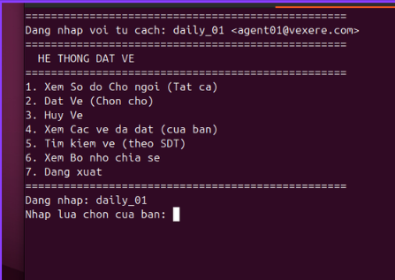
Figure 5 Client 1 (daily_01) logs in and sees initial menu
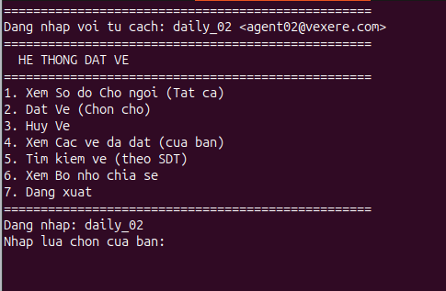
Figure 6 Client 2 (daily_02) logs in and sees initial menu
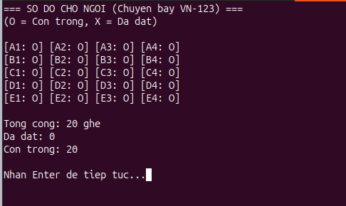
Figure 7 Client view seating chart

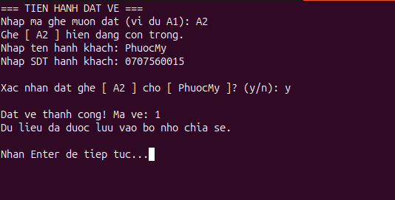
Figure 8 Client 1 proceeds to book a ticket
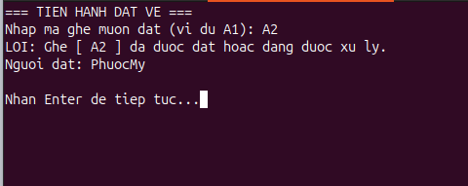
Figure 9 Client 2 booked a ticket and it was already booked by someone else.
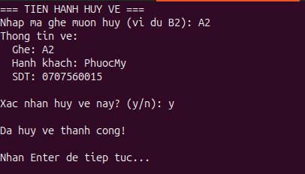
Figure 10 Client 1 proceeds to cancel the ticket.
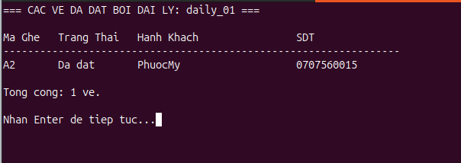
Figure 11 Check the tickets that have been booked.
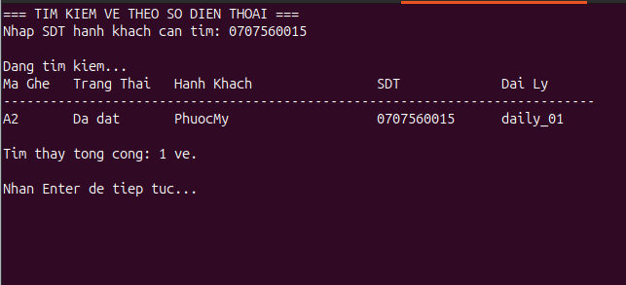
Figure 12 Search for tickets by phone number
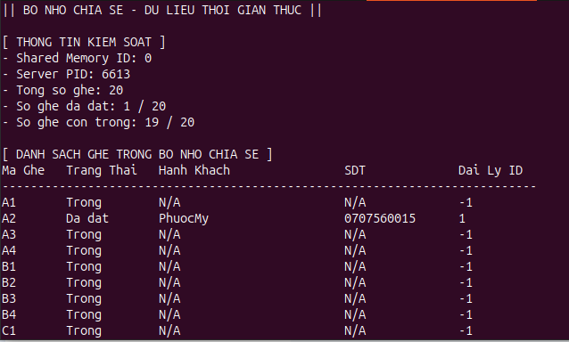
Figure 13 View process shared memory

CONCLUSION

Summary of Findings
This project was carried out to gain practical insights into Inter-Process Communication by implementing a Ticket Booking System using System V Shared Memory and Semaphores.
The demonstration consists of two main programs:
- A Server process, which creates and initializes a shared memory segment. This segment acts as a centralized, in-memory database containing the system's core data: the seat map, agent list, and control statistics.
- Multiple Client processes, which represent concurrent ticket agents. Each client attaches to the same shared memory segment created by the server.
This setup demonstrates a high-performance, concurrent access model. All agents can read and modify the live seat map directly in RAM, illustrating a "zero-copy" mechanism where data is not passed, but shared. The project highlights how System V IPC can be used to build a real-time, multi-user transactional system. Crucially, it also exposes the primary challenge of such a system: data integrity, which is solved using an explicit synchronization mechanism to prevent race conditions.

Evaluation of Shared Memory IPC
Shared memory provides an extremely high-performance communication mechanism because data does not need to be copied through the kernel. As seen in the Ticket Booking System, all client processes can access and query the large seat map instantly, as if it were local memory. Using alternatives, such as pipes or sockets, would require serializing and copying the entire dataset to each client, resulting in significant latency and overhead.
However, this performance comes with the critical responsibility of managing access. The Ticket System demonstration highlights this requirement: a System V Semaphore is necessary to synchronize access to the shared data. Without the semaphore acting as a mutex, a race condition could easily occur, leading to double-bookings and data corruption.
This demonstrates that shared memory is rarely used in isolation; it must almost always be paired with a synchronization primitive, such as a semaphore, to ensure data integrity and safe concurrent access.

Limitations Encountered
While the System V IPC mechanism proved effective, several significant design limitations were identified. The primary challenge stems from the coarse-grained synchronization strategy: a single, system-wide semaphore was used to ensure data integrity. While this approach successfully prevents all race conditions, it creates a major performance bottleneck by forcing all processes even those operating on non-conflicting data to wait, thereby limiting true concurrency. Furthermore, the system's reliance on a statically allocated shared memory segment (defined at compile-time) means its scale is fixed, and it cannot dynamically adapt to larger seat maps or more agents without recompilation. Finally, the system state is entirely volatile, as it exists only in RAM. This lack of data persistence means that if the server crashes or shuts down, all booking records are permanently lost, rendering the system unsuitable for applications requiring data reliability.

REFERENCES
- B. W. Kernighan và D. M. Ritchie, The C Programming Language. Englewood Cliffs, NJ: Prentice Hall, 1988.
[2] A. Silberschatz, P. B. Galvin, và G. Gagne, Operating System Concepts. Hoboken, NJ: Wiley, 2012.
[3] GeeksforGeeks, "System Programs in Operating System," GeeksforGeeks. https://www.geeksforgeeks.org/operating-systems/system-programs-in-operating-system/.
[4] GeeksforGeeks, "What is a Shared Memory?," GeeksforGeeks. https://www.geeksforgeeks.org/computer-organization-architecture/what-is-a-shared-memory/.
[5] Tutorialspoint, "Inter Process Communication - Shared Memory," Tutorialspoint. https://www.tutorialspoint.com/inter_process_communication/inter_process_communication_shared_memory.htm.
[6] B. Hall, "Beej's Guide to Unix Interprocess Communication," Beej's Guides. https://beej.us/guide/bgipc/html/split/shm.html.
[7] Oracle, "System V Shared Memory," Oracle Solaris Programming Interfaces Guide. https://docs.oracle.com/cd/E19683-01/816-5042/svipc-41256/index.html.

